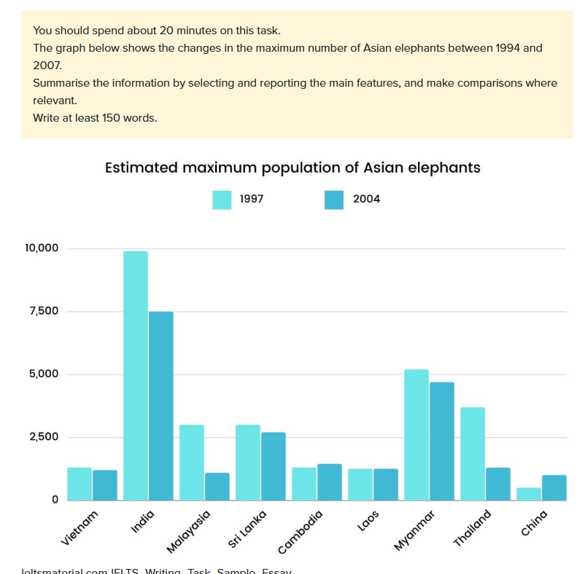

The bar chart shares insight into the modification of Asian elephants from 1997 to 2004. In general, Almost elephants tended to decreasing compare to previous years. However, India elephants were the highest.

Looking to the chart, India remained the country with by far the largest elephant population, but having a dramatic decline in the seven years. China had the least number of elephants which was approximately a half of thousand in 1997 and increased to a thousand in 2004. Although the trend was decreasing in the graph, Laos and Vietnam stayed steady and almost same, just a thousand. Cambodia’s elephants increased slightly, from a thousand in 1997 to 1200 in 2004. Myanmar is the second place with over 5000, but having a reducing in 2004 by approximately 4800. The number of elephants in Malaysia was over 2500, same as Sri Lanka in 1997, but having a dramatic change in 2004, which was a thousand Malaysia’s elephants and 2100 Sri Lanka’s elephants